IoT-Based Smart Agriculture System

**VIT-AP UNIVERSITY**

**P. GEETHA SHANKAR**

# Abstract

Smart farming, precision agriculture, and Agriculture 4.0 involve the integration of advanced technologies into traditional farming. These methods aim to increase productivity and product quality while reducing operational costs. The adoption of smart technologies in agriculture has become essential due to economic pressures and environmental regulations.  
  
The global smart agriculture market was valued at approximately USD 10.2 billion in 2016 and is projected to reach USD 38.1 billion by 2024. Technologies such as drones, precision seeding, auto-steering systems, automatic feeders, and fruit-picking robots are encouraging traditional agri-companies to invest in smart agriculture. These innovations improve operational efficiency, reduce labor dependency, and enhance sustainability.

# Chapter 1: Introduction

The UN Food and Agriculture Organization projects that the world will need to produce 70% more food by 2050 to meet population demands. At the same time, arable land and natural resources are shrinking, and agricultural labor is declining globally.  
  
The Internet of Things (IoT) addresses these challenges by improving productivity, efficiency, and environmental sustainability. IoT enables "precision agriculture," where resources are optimally used through connected sensors, devices, and software solutions.  
  
A BI Intelligence survey estimated 75 million IoT devices would be used in agriculture by 2020, with the market expected to reach USD 15.3 billion by 2025.

# **CHAPTER 2: Problem Statement**

Traditional farming methods rely heavily on manual observation and labor, resulting in inefficient use of water, delayed responses to environmental changes, and increased operational costs. Farmers often lack timely data about soil moisture, temperature, and humidity, which are critical for making informed irrigation decisions. Additionally, the declining availability of agricultural labor adds further strain to already overburdened systems. There is a pressing need for an automated, scalable, and cost-effective solution that can monitor field conditions in real-time and autonomously manage irrigation. This project aims to address these issues by developing an IoT-enabled smart agriculture system that minimizes human intervention while maximizing resource efficiency and crop productivity.

# Chapter 3: Working Principle

This project aims to automate agriculture using IoT sensors that monitor soil moisture, temperature, and humidity to optimize irrigation and crop care.  
  
Block Diagram Overview:  
- Sensors: Soil moisture and DHT22 (temperature & humidity)  
- Microcontroller: Arduino  
- Communication: ESP8266 via UART  
- Actuator: Pump controlled by NPN transistor

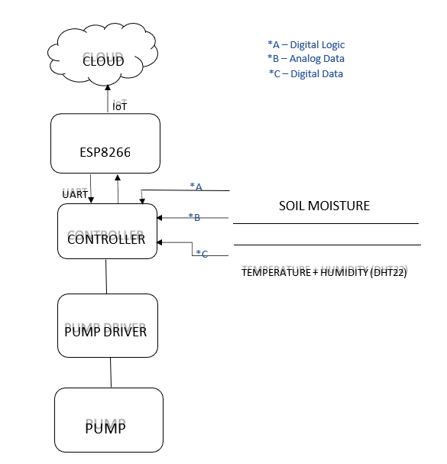

Data Flow:  
- Sensors → Controller (Arduino) → ESP8266 → Cloud  
- Controller → LCD Display + Pump Driver

The power circuit uses a 9V adapter, with voltage regulators (7805 and 1117) providing 5V and 3.3V respectively to sensors and microcontrollers. Sensor data is processed by the Arduino and then used to control the pump, update the LCD, and send information to the cloud.

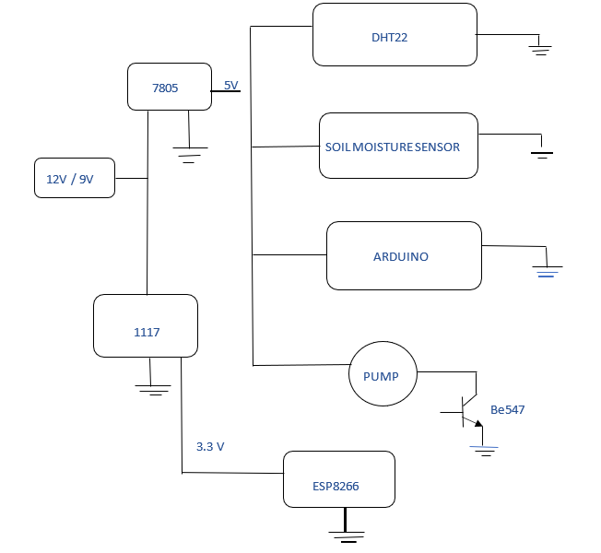

# Chapter 4: Flowchart & Workflow

Flowchart Steps:  
1. Start  
2. Read sensor values (moisture, temperature, humidity)  
3. Send data via Wi-Fi to server  
4. Display data on LCD  
5. Control pump based on sensor data  
6. End

Workflow Explanation:  
- Power from adapter is regulated and distributed to sensors and microcontroller.  
- Sensor data is processed by the Arduino.  
- Outputs:  
 1. Displayed on LCD.  
 2. Sent to cloud using ESP8266.  
 3. Activates pump if soil is dry.

# Chapter 5: Software Program

#include <SPI.h>

#include <Adafruit_GFX.h>

#include <Adafruit_PCD8544.h>

#include <DHT.h>

#include <ArduinoJson.h>

#define DHTPIN 12

#define DHTTYPE DHT22

DHT dht(DHTPIN, DHTTYPE);

Adafruit_PCD8544 display = Adafruit_PCD8544(6, 5, 4, 3, 2);

void setup() {

Serial.begin(9600);

display.begin();

display.setContrast(35);

display.clearDisplay();

display.setTextSize(1);

display.setTextColor(BLACK);

display.setCursor(0, 0);

display.println(" IoT Based");

display.println("Smart Farming");

display.display();

delay(2000);

display.clearDisplay();

pinMode(13, OUTPUT);

pinMode(11, INPUT);

digitalWrite(13, LOW);

dht.begin();

}

void loop() {

float h = dht.readHumidity();

float t = dht.readTemperature();

float m = abs(100 - (analogRead(A0) / 10.23));

if (isnan(h) || isnan(t)) {

Serial.println("Failed to read from DHT sensor!");

return;

}

int it = t * 100;

int ih = h * 100;

int im = m;

bool pc = digitalRead(11);

digitalWrite(13, pc);

display.clearDisplay();

display.setCursor(0, 0);

display.println("Smart Farming");

display.print("Temp: "); display.println(t, 1);

display.print("Hum: "); display.println(h, 1);

display.print("Soil: "); display.println(m, 0);

if (pc == 1) display.print("Pump on");

display.display();

StaticJsonDocument<200> doc;

doc["it"] = it;

doc["ih"] = ih;

doc["im"] = im;

doc["pc"] = pc;

serializeJson(doc, Serial);

delay(500);

}

# Conclusion

The proposed IoT-based smart agriculture system effectively addresses the major challenges of modern farming, including water inefficiency, labor shortages, and lack of real-time monitoring. By using sensors, automation, and cloud connectivity, this system offers a reliable and scalable solution for precision farming. It not only conserves resources but also enhances crop yield and reduces the need for human intervention, paving the way for sustainable agricultural practices.